Ko MARKET STALL ALLOCATION SYSTEM
COMP 102 – INTRODUCTION TO DATABASE

Table of Contents
1. Introduction
2. Project Objectives
3. System Background
4. Refined Physical Data Model
5. Database Design Decisions
6. Database Implementation
7. Table Creation Scripts
8. Sample Data Insertion
9. Data Manipulation Operations
10. SQL Queries and Results
11. User Management and Security
12. Screenshots
13. Challenges Encountered
14. Conclusion
15. GitHub Repository Link

Introduction
The Market Stall Allocation System was developed to improve the management of market stalls within a public market environment. The system stores and manages information about traders, stalls, allocations, inspectors and inspection records.

Project Objectives
Create a relational database using MySQL, manage trader and stall records, demonstrate SQL operations and implement user management.

System Background
The system supports SDG 11 Sustainable Cities and Communities by improving market administration and record keeping.

Refined Physical Data Model
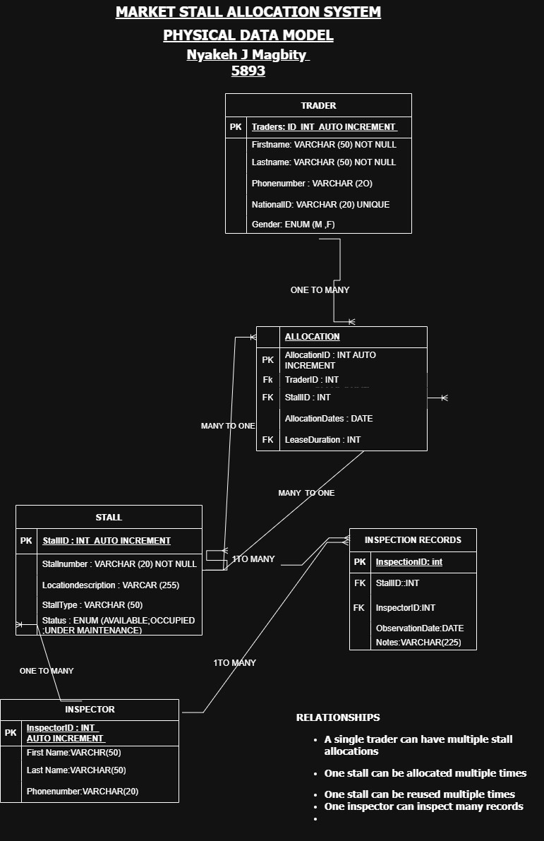

Database Design Decisions
- Primary keys, foreign keys, ENUM fields, unique constraints and normalization techniques were used. Primary Keys were used to uniquely identify records in each table.
- Foreign Keys were used to create relationships between tables and maintain data integrity.
- ENUM Fields were used for Gender and Status to allow only valid values.
- Unique Constraints were applied to NationalID and StallNumber to prevent duplicates.
- Normalization was used to organize data into separate tables and reduce redundancy.

Database Implementation
Implemented using XAMPP, MySQL and phpMyAdmin. The database was implemented using XAMPP, MySQL, and phpMyAdminThe implementation process involved creating the database, creating tables, defining relationships using primary and foreign keys, inserting sample data, and executing SQL queries to test the system’s functionality.

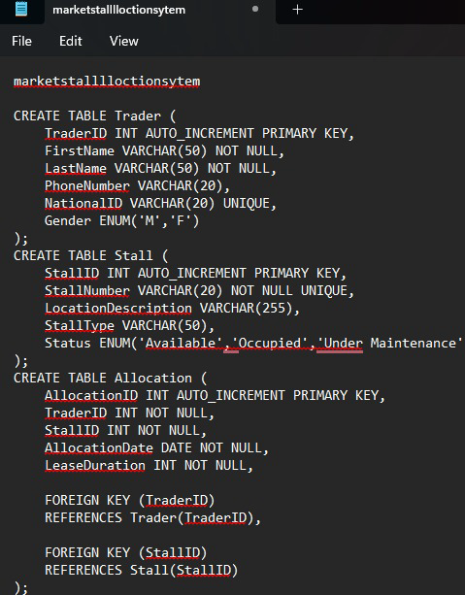
Table Creation Scripts
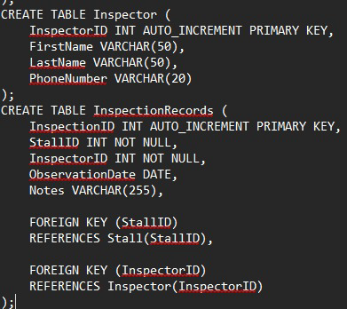

Sample Data Insertion
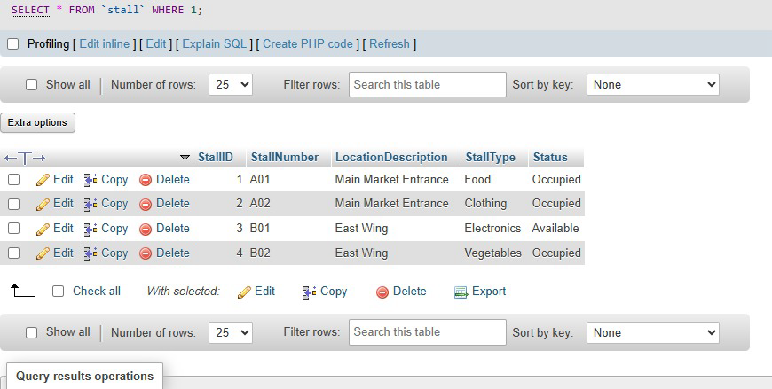
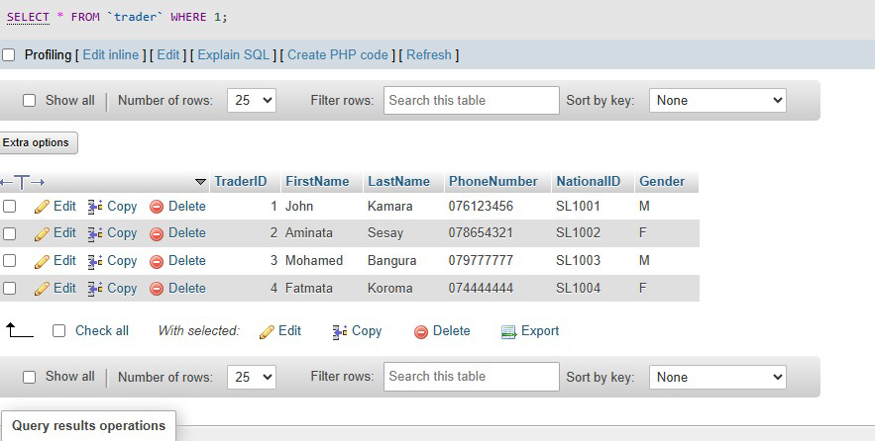
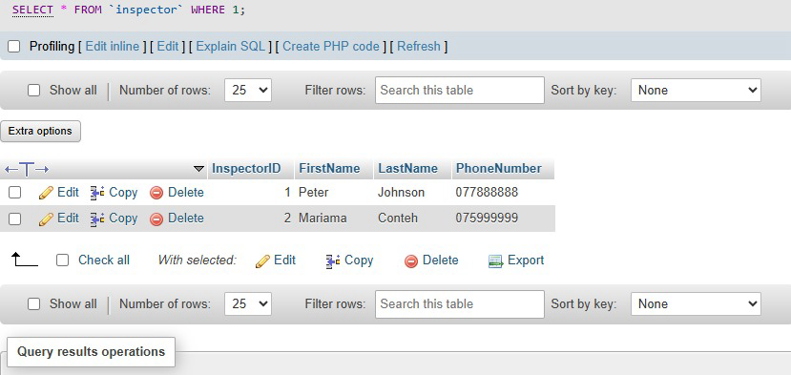
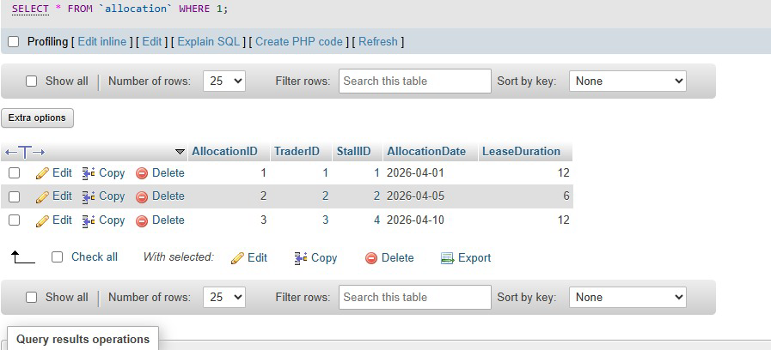
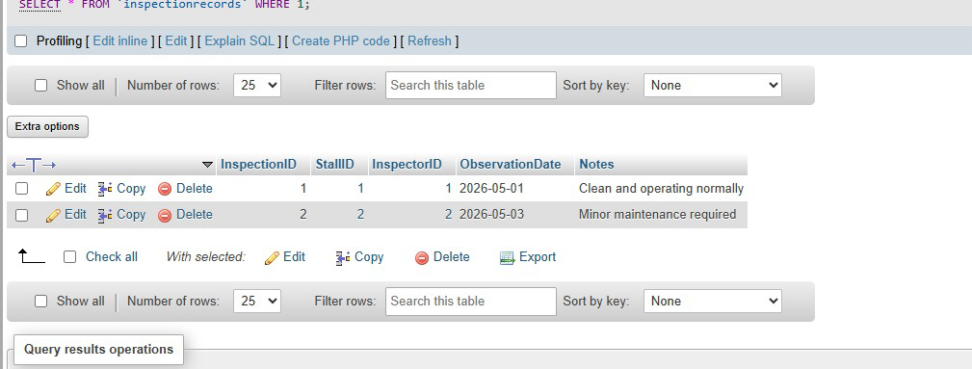

Data Manipulation Operations
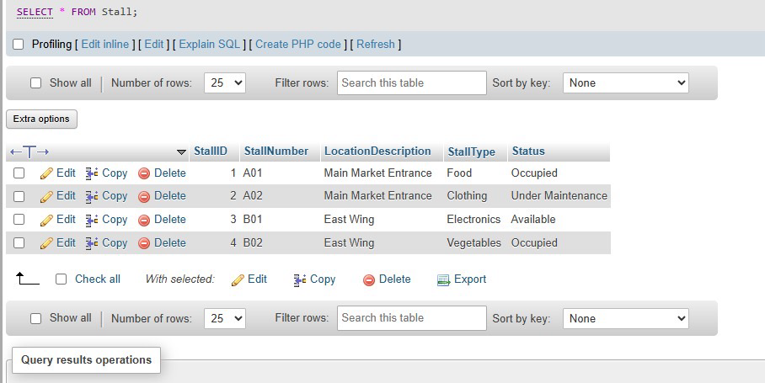

SQL Queries and Results
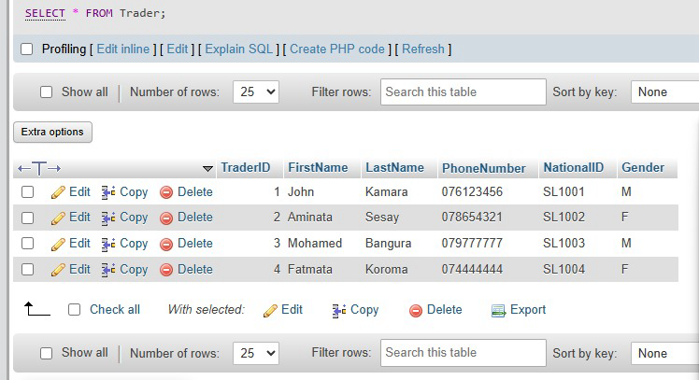
SELECT quarries

WHERE, query
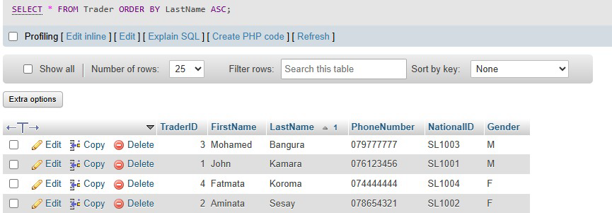
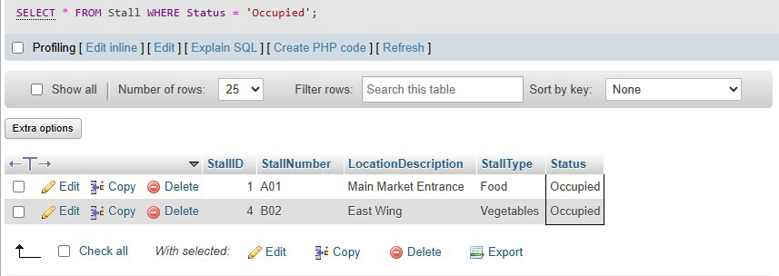
ORDER BY, query
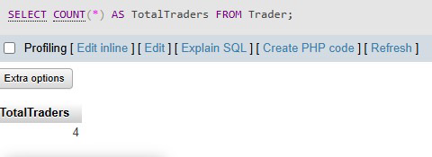
COUNT, query

GROUP By, query
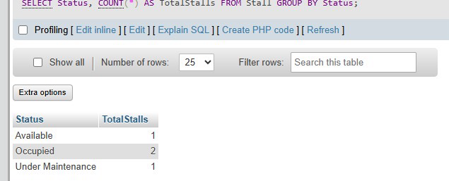
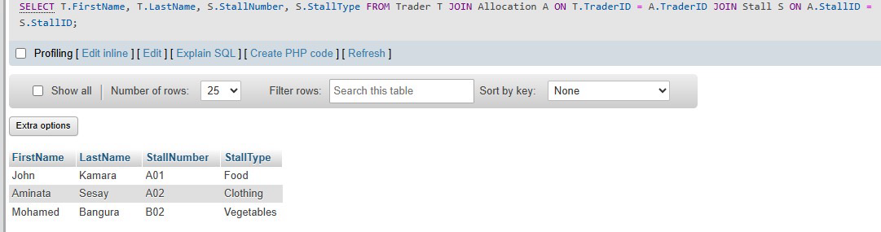
JOIN query outputs.

User Management and Security
User management was implemented to control access to the database and improve security. MySQL user accounts were created, passwords were assigned, and privileges were granted to authorized users.
User Creation

The following command was used to create a new database user:
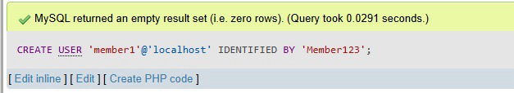

Password Change
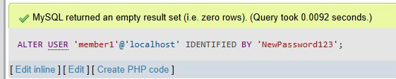
The following command was used to change the user’s password:

Privilege Assignment
The following command was used to grant privileges to the user:
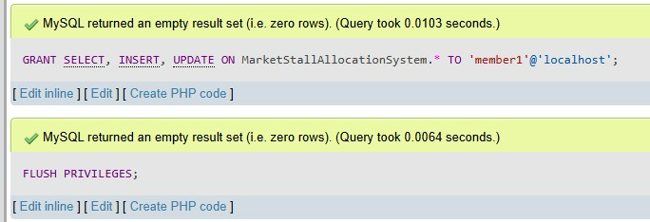

Challenges Encountered
During the development of the Market Stall Allocation System, several challenges were encountered. One of the main challenges was understanding and implementing relationships between tables using primary and foreign keys. This was resolved by carefully designing the Physical Data Model and testing the relationships in MySQL.Another challenge was correcting SQL syntax errors while creating table andexecuting queries. These errors were identified and fixed through debugging and repeated testing in phpMyAdmin. There were also difficulties in inserting data in the correct order because some tables depended on foreign key relationships. This issue was solved by inserting data into parent tables before inserting data into related child table

.

Conclusion
The project successfully demonstrates the implementation of a Market Stall Allocation System using MySQL.

